**Smoke detectors:**

Smoke Detectors arevery useful in detecting smoke or fire in buildings, and so are the important safety parameters. In this DIY session, we are going to build a **Smoke Detector Circuit** which not only sense the smoke in the air but also reads and **displays the level of Smoke in the Air in PPM** (parts per million). This circuit triggers the Buzzer when Smoke level becomes higher than 1000 ppm, this threshold value can be changed in the Code according to the requirement. This circuit mainly uses **MQ2 Smoke/Gas sensor and Arduino** to detect and calculate the level of smoke. **MQ2 gas sensor**is also sensible to LPG, Alcohol, and Methane etc.

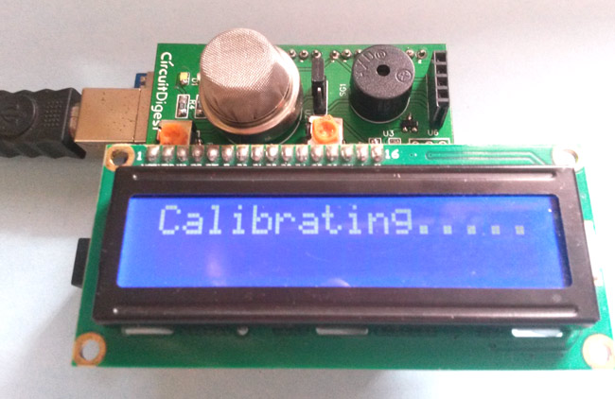

This Smoke Detector can be easily built on Bread Board or Dot Board but we have decided to build this as an Arduino Shield on PCB. We have used **EasyEDA** online PCB simulator and designer to build this **Smoke Detector Shield for Arduino**. We have explained the whole process in this Article and also provided PCB layout for this Arduino Shield so that you can also order this Shield if you need.

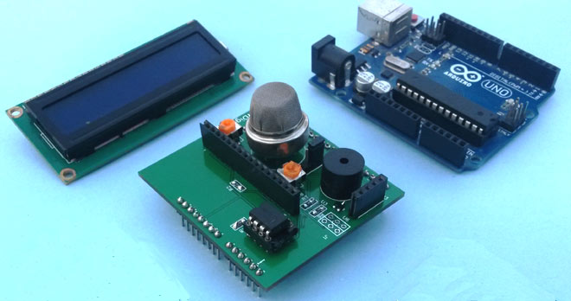

**Components Required:**

* Arduino UNO
* Smoke Detector Arduino Shield (Self Designed)
* Power Supply

**Components for Smoke Detector Arduino Shield:**

* Smoke Sensor (MQ2)
* Resistors (10K and 1K)
* Buzzer
* 16x2 LCD
* 10k POT
* LED
* LM358
* Burg strips

**Designing Smoke Detector Shield for Arduino:**

For designing **Smoke Detector Shield for Arduino** we have used EasyEDA, in which first we have designed a Schematic and then converted that into the PCB layout by Auto Routing feature of EasyEDA.

To design circuit and PCB for this Smoke Detector Shield, we chose [EasyEDA](https://easyeda.com/" \t "_blank) which is a free online tool and one stop solution for developing your electronics projects with ease. It offers schematic capture, spice simulation, PCB design for free and also offers high quality but low price Customized PCB service. There are a large number of component libraries in its editor, so you can easily and quickly find your desired parts. Check here the complete tutorial on [How to use Easy EDA](http://circuitdigest.com/article/easyeda-for-circuit-design) for making Schematics, PCB layouts, Simulating the Circuits etc.

We have made the Circuit and PCB design of this Smoke Detector Shield public, so you can just follow the link to [access the Circuit Diagram and PCB layouts](https://easyeda.com/circuitdigest/Smoke_Detector_Arduino_Shield-kEQca75rN):

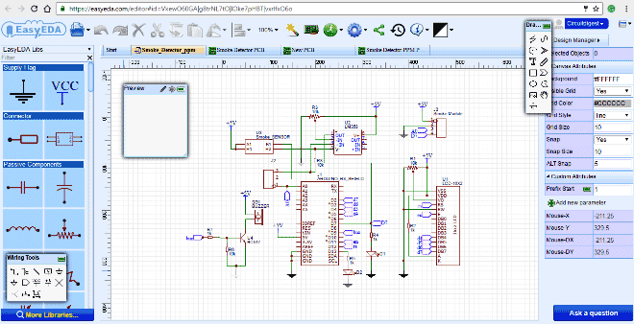

Below is the Snapshot of Top layer of PCB layout from EasyEDA, you can view any Layer (Top, Bottom, Topsilk, bottomsilk etc) of the PCB by selecting the layer form the ‘Layers’ Window.

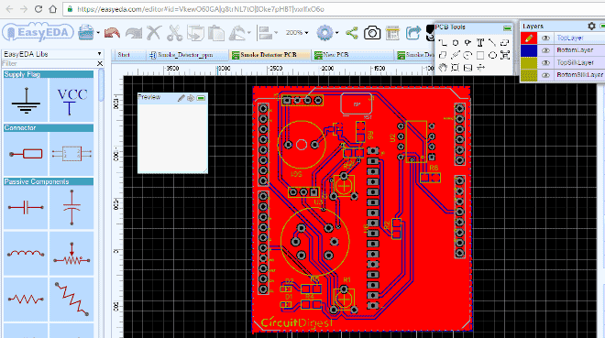

.

### Circuit Explanation:

In this Smoke Detector Circuit with Arduino, we have used a **MQ2 Gas Sensor** to detect preset smoke in the air. A **16x2 LCD is used for displaying the PPM value of Smoke**. And an **LM358 IC** for converting smoke sensor output into digital form (this function is optional). A **buzzer** is placed as an alarm which gets triggered when smoke level goes beyond 1000 PPM.

Circuit connections for this project are very simple, we have a **Comparator Circuit** for comparing output voltage of smoke sensor with preset voltage (output connected at pin D7). Also smoke sensor output is connected at an analog pin of Arduino (A0). Buzzer is connected at Pin D9. And LCD connections are same as Arduino LCD examples that are available in Arduino IDE (12, 11, 5, 4, 3, 2). Remaining connections are shown in the circuit diagram.